HOMEWORK-01
GPIO, Timers, Interrupts, Debouncing & OLED Display
Embedded IoT Systems | Fall 2026 | BSCS 5th A, B
Student Name | Muhammad Bilal Gulzar | Registration No. | 24-NTU-CS-FL-1060
Class / Section | BSCS-B | Submission Date | Oct 13,2026

Report contents: Part A – Theory answers (Q1–Q5) • Part B – Practical lab: wiring, implementation, source code, test results • Evidence W1–H3 • Final checklist.

Part A – Technical Theory
Q1. GPIO configuration and operation
Explain the difference between INPUT, INPUT_PULLUP, and OUTPUT modes on the ESP32. Describe how a push button should be wired when using INPUT_PULLUP, what logic level is read when the button is pressed, and why GPIO selection and voltage limits matter.
Answer
A General-Purpose Input/Output (GPIO) pin of the ESP32 can be configured in software with pinMode() to behave either as an input that reads an external voltage or as an output that drives a voltage. The three Arduino modes differ in how the pin is connected internally:
Mode | What happens inside the pin | Level when nothing is connected | Typical use
INPUT | Pin is high-impedance (no internal pull-up/pull-down). It only senses the voltage applied from outside. | Floating – undefined, picks up noise | Sensors/modules that drive the line themselves; buttons with an external pull-up/pull-down resistor
INPUT_PULLUP | Same as INPUT, but an internal resistor (≈ 45 kΩ) is connected between the pin and 3.3 V. | HIGH (1), held by the pull-up | Push buttons and switches wired between the pin and GND – no external resistor needed
OUTPUT | A push-pull driver actively forces the pin to 3.3 V (HIGH) or 0 V (LOW) using digitalWrite(). | Whatever was last written | LEDs (through a resistor), buzzers/relays (through a transistor), enable lines

Push-button wiring with INPUT_PULLUP. One terminal of the button is connected to the GPIO pin (GPIO 18 in our lab) and the other terminal to GND (Fig. 1). The pin is configured with pinMode(18, INPUT_PULLUP). When the button is released, no current path to GND exists, so the internal pull-up holds the pin at 3.3 V and digitalRead() returns HIGH. When the button is pressed, the contacts connect the pin directly to GND, which overpowers the weak pull-up, and digitalRead() returns LOW. The logic is therefore *active-low*: “pressed” means digitalRead(pin) == LOW.
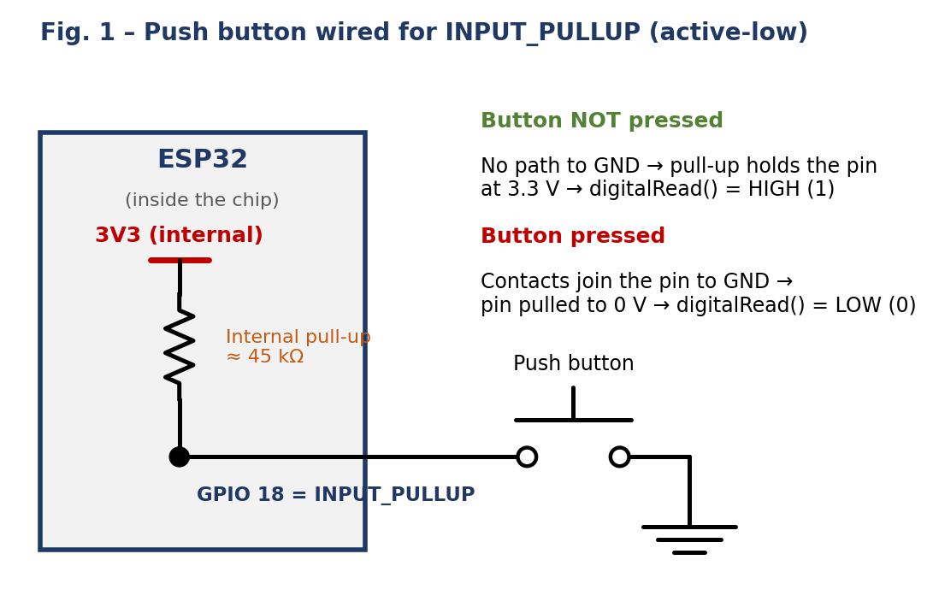

Why GPIO selection and voltage limits matter.
- Logic level is 3.3 V. ESP32 pins are not 5 V tolerant; applying 5 V to a GPIO can permanently damage the chip. Level shifting is needed for 5 V devices.
- Current limits. A pin can only source/sink a few milliamps safely (the absolute maximum is about 40 mA per pin; designers keep it ≈ 10–20 mA or less). LEDs need a series resistor and larger loads need a transistor or driver.
- Not every GPIO is free to use. GPIO 6–11 are connected to the on-board SPI flash and must not be used; GPIO 34–39 are input-only and have no internal pull-up/pull-down, so INPUT_PULLUP does not work on them; strapping pins (GPIO 0, 2, 5, 12, 15) influence the boot mode, so a button or load on them at reset can stop the board from booting (e.g. holding GPIO 0 LOW enters download mode); ADC2 pins cannot be used for analog reads while Wi-Fi is active.
- Choice for this lab. GPIO 18 is a safe general-purpose pin with an internal pull-up, GPIO 21/22 are the default I²C pins – so all three can be used without clashes.
Q2. Timers and non-blocking design
What is the purpose of a timer in an embedded system? Compare delay()-based timing with millis()-based or timer-driven non-blocking timing. Give one practical example where non-blocking timing allows the display, button, and another task to remain responsive.
Answer
A timer is a hardware counter driven by a stable clock. Its purpose is to let the system measure elapsed time, generate periodic events, create timeouts and schedule tasks accurately without the CPU having to count cycles itself. The ESP32 has four 64-bit hardware timers plus the FreeRTOS tick and esp_timer; the Arduino function millis() returns the number of milliseconds since boot, taken from a free-running hardware timer, so it keeps counting in the background while the program does other work.
Aspect | delay(ms) (blocking) | millis() / timer-driven (non-blocking)
CPU behaviour | CPU sits in a wait loop; nothing else in loop() can run. | CPU keeps executing; time is checked with if (millis() - last >= interval).
Responsiveness | Button presses, sensor changes and display updates during the delay are missed or late. | Every task is polled on every pass, so inputs are noticed within microseconds.
Multitasking | Only one time-based activity at a time. | Several independent intervals (LED 500 ms, OLED 100 ms, …) can run together.
Complexity | Very simple to write. | Needs a few state variables (lastTime, flags), but scales well.
Typical use | Quick demos, one-off start-up waits. | Real applications, debouncing, scheduling, communication time-outs.

Practical example. A device must blink a status LED every 500 ms, refresh an OLED every 100 ms and react to a push button. With delay(500) the button could be pressed and released inside the delay without ever being seen, and the OLED would freeze. With millis() each task simply checks its own timer on every pass of loop() (Fig. 2), so all three remain responsive:
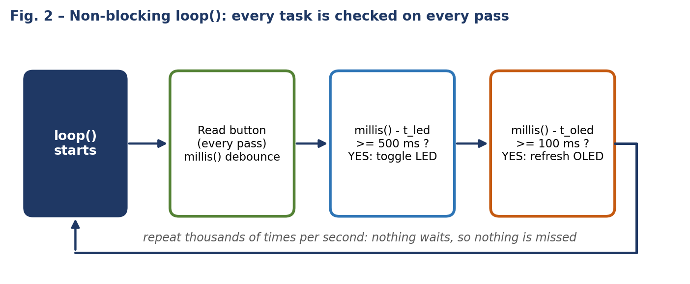

non-blocking example
unsigned long tLed = 0, tOled = 0;

void loop() {
unsigned long now = millis();

readButtonDebounced(); // runs every pass

if (now - tLed >= 500) { tLed = now; digitalWrite(LED, !digitalRead(LED)); }
if (now - tOled >= 100) { tOled = now; refreshOLED(); }
}
Q3. Interrupts and ISR
Define an interrupt and an Interrupt Service Routine (ISR). Explain the sequence from an interrupt event to ISR execution. State at least three good ISR practices for ESP32 Arduino code, and explain why lengthy display updates or Serial printing should generally not be performed inside an ISR.
Answer
An interrupt is a hardware signal that tells the CPU that an event needs immediate attention (for example an edge on a GPIO pin, a timer expiry or a received byte). The CPU temporarily suspends the main program, handles the event and then resumes. The function that handles the event is the Interrupt Service Routine (ISR).
Sequence from event to ISR execution (Fig. 3):
- The event occurs – e.g. a falling edge on GPIO 18 when the button is pressed (configured with attachInterrupt(..., FALLING)).
- The GPIO hardware sets an interrupt flag and the interrupt controller signals the CPU (if that interrupt is enabled and not masked).
- The CPU finishes the current instruction and saves its context (registers/program counter).
- The CPU looks up the handler in the vector table and jumps to the ISR.
- The ISR executes (it should do the minimum, such as setting a flag).
- The saved context is restored and loop() continues exactly where it was interrupted.
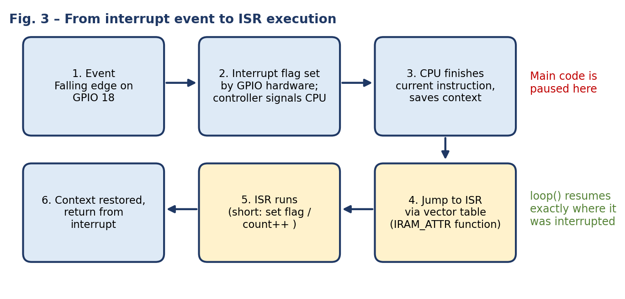

Good ISR practices on ESP32 Arduino code:
- Keep the ISR very short and fast – only set a flag, increment a counter or store a timestamp; do the real work in loop().
- Mark it with IRAM_ATTR so the function is placed in internal RAM and stays executable even when the flash cache is disabled.
- Declare shared variables volatile and protect multi-byte data with a critical section (portENTER_CRITICAL_ISR / spinlock) so loop() and the ISR do not corrupt each other’s data.
- Never call blocking or non-reentrant functions – no delay(), Serial.print(), I²C/OLED calls, malloc/new; use the ...FromISR() variants of FreeRTOS APIs if needed.
- Combine with debouncing – a bouncing button can raise several interrupts per press.
ISR pattern: set a flag, handle it in loop()
volatile bool buttonFlag = false;
void IRAM_ATTR onButton() { buttonFlag = true; } // short ISR

void setup() {
pinMode(18, INPUT_PULLUP);
attachInterrupt(digitalPinToInterrupt(18), onButton, FALLING);
}
void loop() {
if (buttonFlag) { buttonFlag = false; /* debounce, update OLED, print */ }
}
Why display updates and Serial printing do not belong in an ISR. Sending a full 128×64 OLED frame is 1024 bytes over I²C; at 400 kHz this alone takes more than 20 ms (about 9 clock pulses per byte), which is an eternity for an ISR and would block all other interrupts and tasks of lower or equal priority. Serial.print() and the Wire/display libraries use buffers, locks and interrupts of their own, are not designed to be re-entered from an ISR and may block when a buffer is full – this can cause lost events, corrupted output, deadlocks, or a watchdog reset (“Guru Meditation Error / Interrupt WDT timeout”). Therefore the ISR only records that the event happened and the main loop performs the slow display and Serial work.
Q4. Switch debouncing
Explain mechanical switch bounce and why one physical press may be detected as multiple presses. Compare delay-based debouncing with timer/millis()-based debouncing. Describe a reliable state-based method that accepts one press only after the input has remained stable for a chosen debounce interval.
Answer
Switch bounce. A mechanical push button is made of metal contacts and a spring. When the contacts meet (or separate) they do not make a single clean connection: they vibrate and touch/part several times for a few milliseconds (typically 1–20 ms) before settling. The pin voltage therefore shows a burst of rapid HIGH/LOW transitions instead of one clean edge (Fig. 4). The ESP32 reads or reacts to a pin in microseconds, so it is fast enough to see every one of these transitions – a polling loop that counts “HIGH→LOW” changes, or an interrupt on FALLING, registers one physical press as several presses.
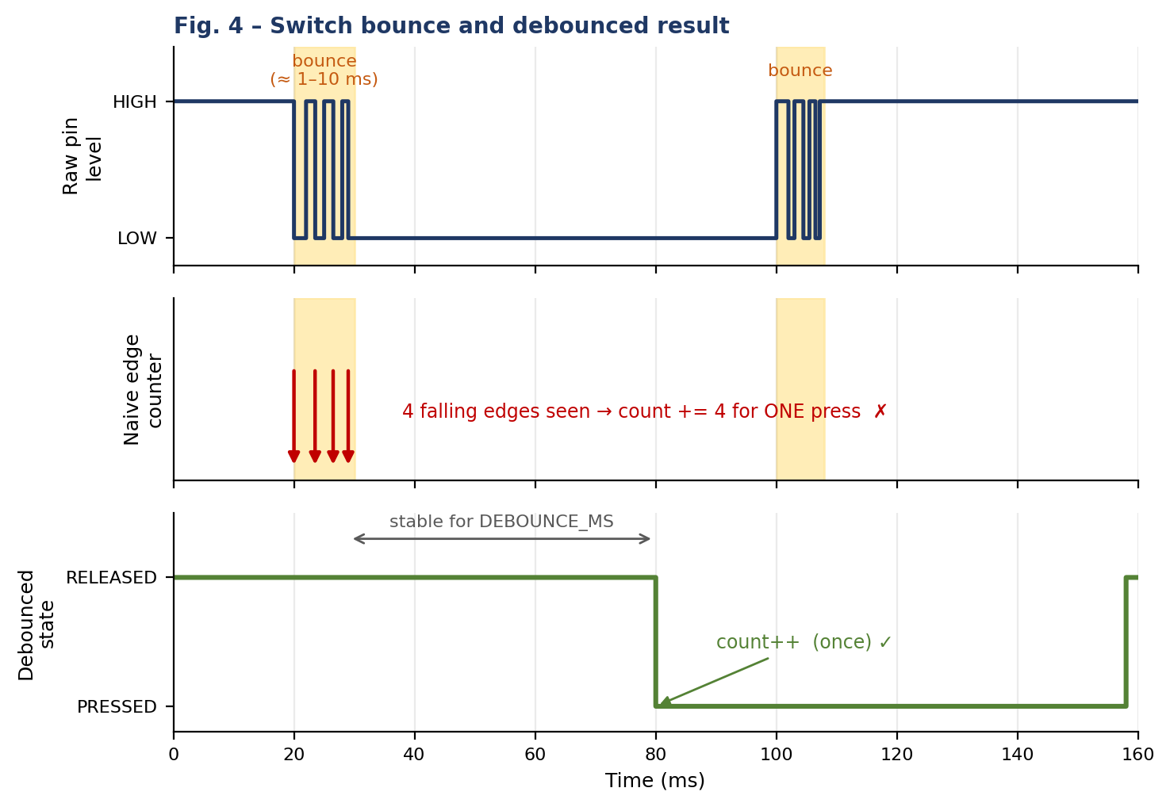

Aspect | Delay-based debouncing | millis()/timer-based debouncing
Idea | On the first edge call delay(50), then read the pin again. | Record the time of the last change and accept the state only after it stays unchanged for the interval.
CPU use | Blocks for the whole delay – OLED, Serial, other buttons and tasks freeze. | Non-blocking – loop() keeps running, the check costs microseconds.
Reliability | May miss a quick second press, and a long delay makes the system feel sluggish. | Handles press and release separately; behaves consistently while other tasks run.
Use in this lab | Not allowed (“no long blocking delay”). | Used – DEBOUNCE_MS = 50.

Reliable state-based method. The program keeps three pieces of state: lastReading (last raw pin level), stableState (last accepted level) and lastChangeTime. On every pass of loop() (Fig. 5):
- Read the pin. If it differs from lastReading, store lastReading = reading and restart the timer: lastChangeTime = millis() (bounce keeps resetting the timer).
- If the reading has stayed the same for at least DEBOUNCE_MS (millis() - lastChangeTime >= DEBOUNCE_MS), the signal is considered stable.
- If this stable value differs from stableState, a genuine change has occurred: update stableState; when the new state is LOW (pressed) increment the counter exactly once.
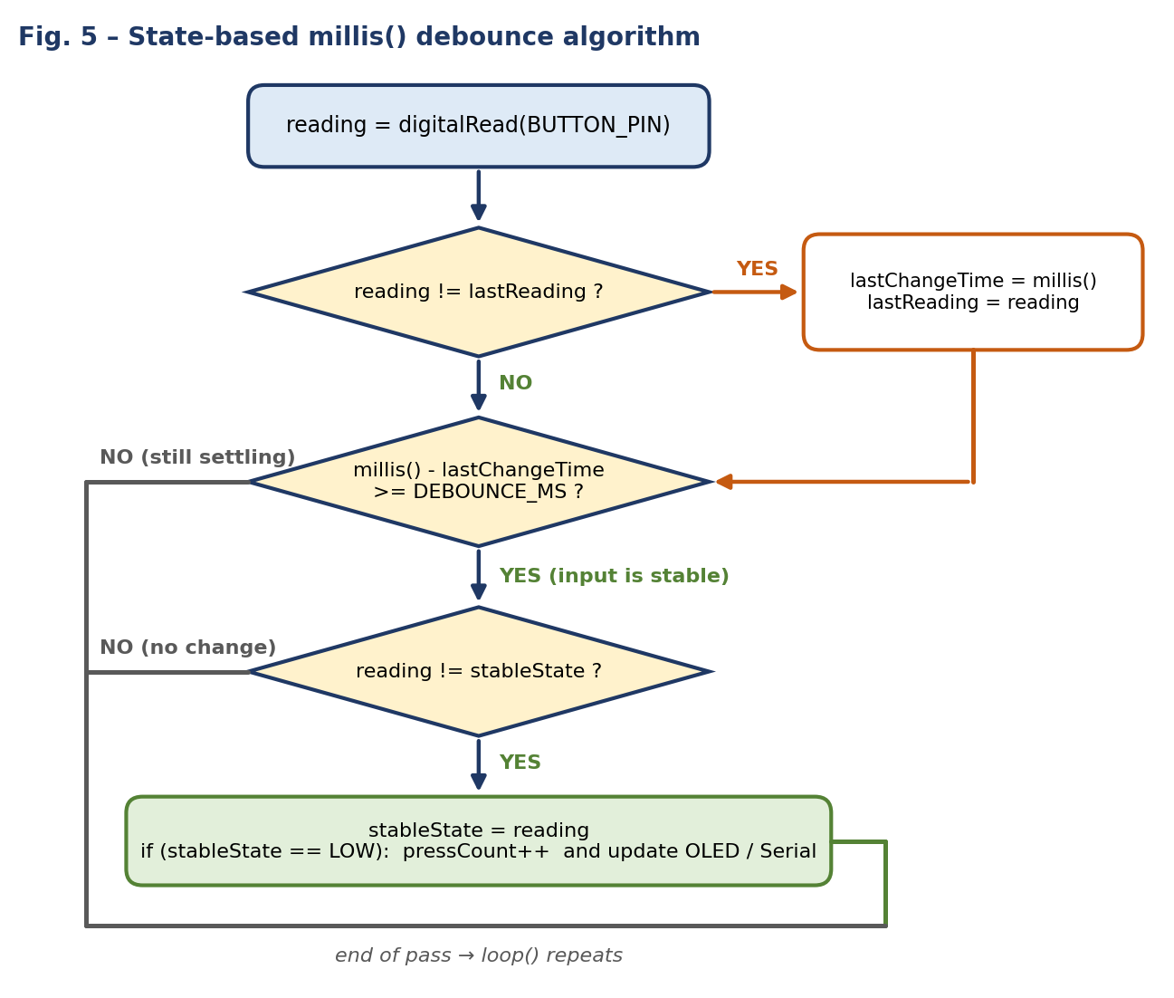

debounce core
if (reading != lastReading) { lastChangeTime = millis(); lastReading = reading; }

if ((millis() - lastChangeTime) >= DEBOUNCE_MS && reading != stableState) {
stableState = reading;
if (stableState == LOW) pressCount++; // exactly one count per press
}
Q5. OLED display and I²C
Describe how an SSD1306 OLED communicates with the ESP32 using I²C. Identify the purpose of SDA, SCL, VCC, and GND; state the usual ESP32 connections and address used in our lab; and explain the roles of display initialization, drawing text, and display.display() (or the library's equivalent refresh call).
Answer
I²C (Inter-Integrated Circuit) is a two-wire, synchronous serial bus. The ESP32 acts as the master: it generates the clock and starts every transfer. The SSD1306 OLED is the slave and is selected by its 7-bit address. Both lines, SDA and SCL, are open-drain and are pulled up to 3.3 V by resistors (usually 4.7 kΩ, already fitted on the OLED module). A transfer consists of: START condition → slave address + R/W bit → ACK from the slave → command/data bytes (each acknowledged) → STOP condition. Several devices can share the same two wires as long as their addresses differ.
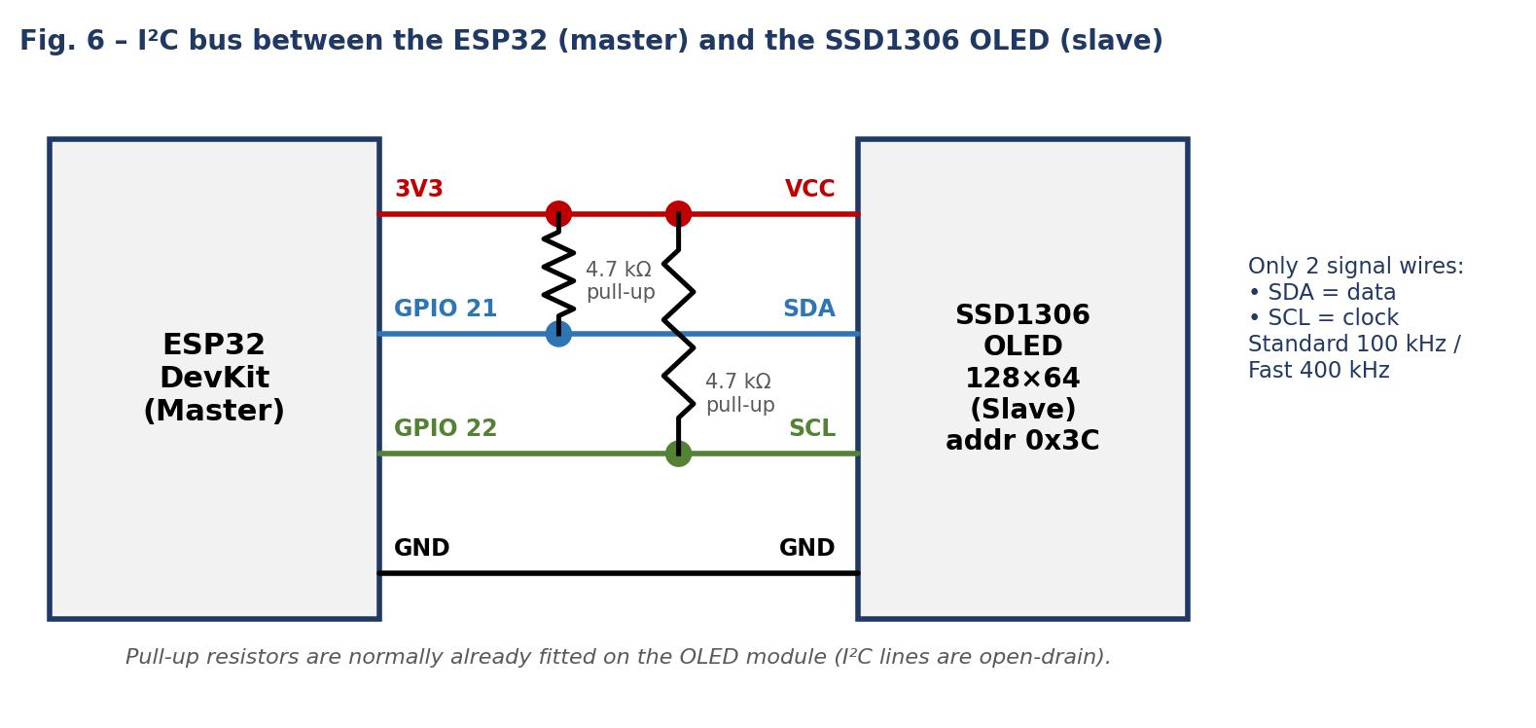

OLED pin | ESP32 connection | Purpose
VCC | 3V3 | Power supply of the display (use the module’s supported voltage; 3.3 V in our lab).
GND | GND | Common ground / reference for power and signals.
SDA | GPIO 21 | Serial Data line – carries the address, commands and display data in both directions.
SCL | GPIO 22 | Serial Clock line – generated by the ESP32 to time every bit on SDA.

The usual I²C address of the SSD1306 module used in our lab is 0x3C (some modules use 0x3D). A wrong address is the most common reason for a blank display.
Roles of the key steps:
- Initialization – Wire.begin(21, 22) starts the I²C peripheral on the chosen pins; display.begin(SSD1306_SWITCHCAPVCC, 0x3C) allocates a 1 KB frame buffer (128×64 pixels ÷ 8) in ESP32 RAM and sends the start-up command sequence (clock, multiplex ratio, charge pump, contrast, display ON). It returns false if the OLED does not respond.
- Drawing text – clearDisplay(), setTextSize(), setTextColor(), setCursor() and print() only modify the frame buffer in the ESP32’s RAM. Nothing is visible on the OLED yet.
- display.display() – copies the whole frame buffer to the SSD1306’s internal graphics memory over I²C, which is the moment the screen actually changes. Because a full refresh takes ≈ 20–25 ms at 400 kHz, it is called only when the content changes.
OLED sequence
Wire.begin(21, 22);
display.begin(SSD1306_SWITCHCAPVCC, 0x3C); // initialise
display.clearDisplay(); // clear buffer
display.setTextSize(1); display.setTextColor(SSD1306_WHITE);
display.setCursor(0, 0); display.print("Hello"); // draw into buffer
display.display(); // send buffer to the OLED

Part B – Practical Lab

Task: ESP32 OLED status display with a debounced push button
The project initialises an SSD1306 OLED, shows a title, the button status (PRESSED / RELEASED) and a press counter that starts at 0. Each valid physical press increases the counter exactly once. Debouncing is done without a blocking delay using millis(), and the accepted press count is printed on the Serial Monitor. The same code was built with PlatformIO, simulated in Wokwi and run on the physical ESP32 kit.

1. Wiring / pin table
Component / pin | ESP32 connection | Notes
SSD1306 OLED VCC | 3V3 | Module supply voltage (3.3 V).
SSD1306 OLED GND | GND | Common ground.
SSD1306 OLED SDA | GPIO 21 | I²C data line.
SSD1306 OLED SCL | GPIO 22 | I²C clock line.
Push button (leg 1) | GPIO 18 | Configured as INPUT_PULLUP; pressed reads LOW.
Push button (leg 2) | GND | Completes the active-low button circuit.
OLED I²C address: 0x3C. Button pin: GPIO 18 (the suggested pin; no other pin was required).
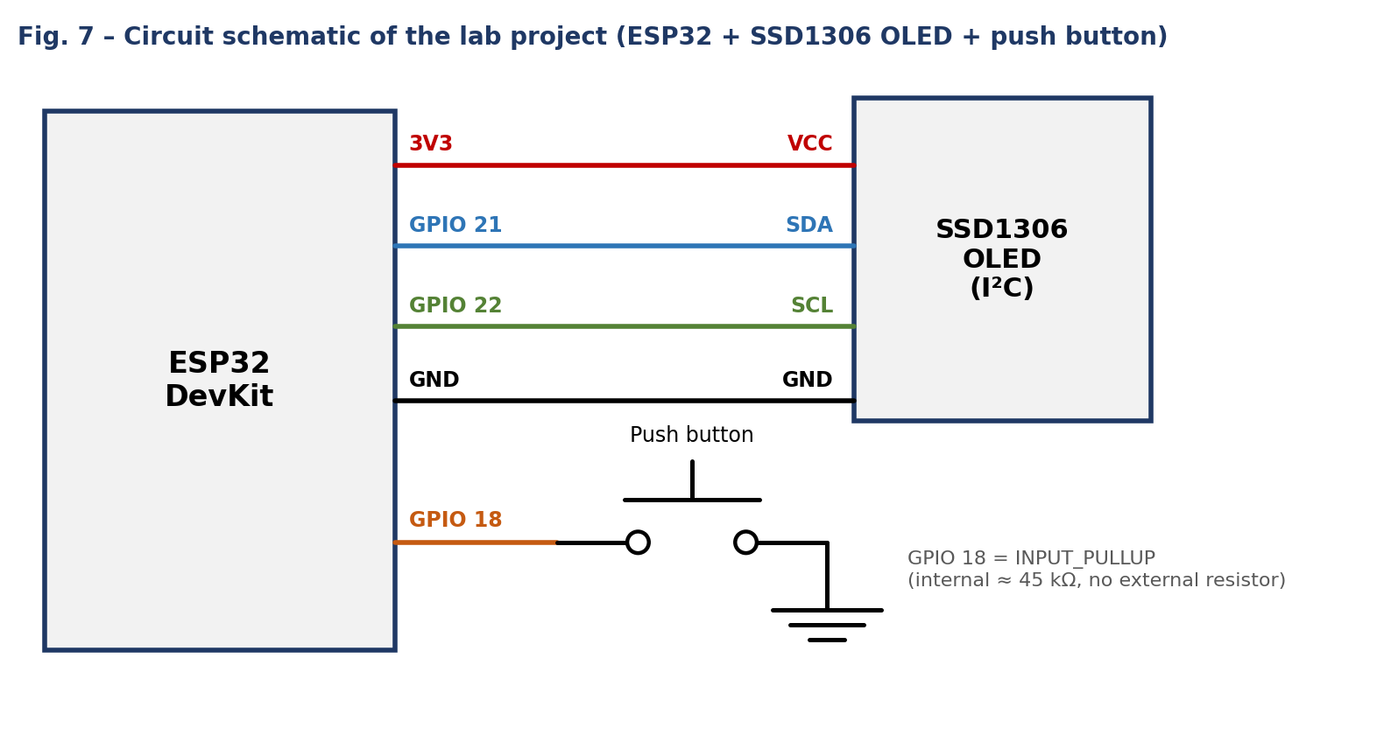

2. Implementation explanation
- setup() – starts Serial at 115200 baud, sets GPIO 18 to INPUT_PULLUP, starts I²C on GPIO 21/22, initialises the SSD1306 at 0x3C and draws the first screen with the counter at 0.
- loop() – reads the button on every pass. When the raw level changes it only restarts the stability timer (lastChangeTime). Once the level has stayed the same for DEBOUNCE_MS = 50 ms and differs from stableState, the change is accepted.
- One count per press – bounce pulses keep resetting the timer, so they are never accepted; the counter is incremented only on the accepted HIGH→LOW transition, so holding the button down does not repeat the count. The release is debounced in the same way.
- Display and Serial – drawScreen() redraws the title, “Button: PRESSED/RELEASED” and “Count: n” and is called only when the accepted state changes, which avoids needless I²C traffic. The Serial Monitor prints “Accepted press #n” for each valid press.
- Non-blocking – there is no delay() in loop(), so the program stays responsive.

3. Source code
src/main.cpp
#include <Wire.h>
#include <Adafruit_GFX.h>
#include <Adafruit_SSD1306.h>

#define SCREEN_WIDTH 128
#define SCREEN_HEIGHT 64
#define OLED_RESET -1
#define BUTTON_PIN 18

Adafruit_SSD1306 display(
SCREEN_WIDTH, SCREEN_HEIGHT, &Wire, OLED_RESET
);

int buttonCount = 0;
int lastButtonState = HIGH;

void setup() {
pinMode(BUTTON_PIN, INPUT_PULLUP);

Serial.begin(115200);

if (!display.begin(SSD1306_SWITCHCAPVCC, 0x3C)) {
Serial.println("OLED not found!");
while (true) {
delay(100);
}
}

display.clearDisplay();
display.setTextColor(SSD1306_WHITE);
display.setTextSize(1);
display.setCursor(10, 10);
display.println("Button Counter");
display.setCursor(10, 30);
display.println("Presses: 0");
display.display();
}

void loop() {
int buttonState = digitalRead(BUTTON_PIN);

// Count only when the button is pressed
if (lastButtonState == HIGH && buttonState == LOW) {
buttonCount++;

display.clearDisplay();
display.setTextColor(SSD1306_WHITE);

display.setTextSize(1);
display.setCursor(10, 5);
display.println("Button Counter");

display.setTextSize(2);
display.setCursor(10, 25);
display.print("Count: ");
display.println(buttonCount);

display.display();

Serial.print("Button presses: ");
Serial.println(buttonCount);

delay(200); // Simple debounce
}

lastButtonState = buttonState;
}

platformio.ini
[env:esp32dev]
platform = espressif32
board = esp32dev
framework = arduino
monitor_speed = 115200
lib_deps =
adafruit/Adafruit SSD1306@^2.5.9
adafruit/Adafruit GFX Library@^1.11.9
wokwi.toml
[wokwi]
version = 1
firmware = '.pio/build/esp32dev/firmware.bin'
elf = '.pio/build/esp32dev/firmware.elf'

diagram.json
{
"version": 1,
"author": "Your Name",
"editor": "wokwi",
"parts": [
{ "type": "wokwi-esp32-devkit-v1", "id": "esp", "top": 0, "left": 0, "attrs": {} },
{ "type": "board-ssd1306", "id": "oled", "top": -120, "left": 160, "attrs": { "i2cAddress": "0x3c" } },
{ "type": "wokwi-pushbutton", "id": "btn1", "top": 130, "left": 200, "attrs": { "color": "green" } }
],
"connections": [
[ "esp:TX0", "$serialMonitor:RX", "", [] ],
[ "esp:RX0", "$serialMonitor:TX", "", [] ],
[ "esp:3V3", "oled:VCC", "red", [ "v0" ] ],
[ "esp:GND.1", "oled:GND", "black", [ "v0" ] ],
[ "esp:D21", "oled:SDA", "blue", [ "v0" ] ],
[ "esp:D22", "oled:SCL", "green", [ "v0" ] ],
[ "esp:D18", "btn1:1.l", "orange", [ "v0" ] ],
[ "esp:GND.2", "btn1:2.l", "black", [ "v0" ] ]
],
"dependencies": {}
}

4. Project structure
esp32_oled_button/
├── platformio.ini # board, framework and libraries
├── wokwi.toml # points Wokwi to the compiled firmware
├── diagram.json # Wokwi circuit (ESP32 + SSD1306 + button)
└── src/
└── main.cpp # application code

Test Results
Fill the Observed count and Pass? columns while testing (Pass if the observed count equals the expected count after that press). Add notes about any missed or double counts.

Wokwi simulation – press-by-press test
Press # | Expected count | Observed count | Pass? (Yes / No)
1 | 1 | 1 | Y
2 | 2 | 2 | Y
3 | 3 | 3 | Y
4 | 4 | 4 | Y
5 | 5 | 5 | Y
6 | 6 | 6 | Y
7 | 7 | 7 | Y
8 | 8 | 8 | Y
9 | 9 | 9 | Y
10 | 10 | 10 | Y

Physical hardware – press-by-press test
Press # | Expected count | Observed count | Pass? (Yes / No)
1 | 1 | 1 | Y
2 | 2 | 2 | Y
3 | 3 | 3 | Y
4 | 4 | 4 | Y
5 | 5 | 5 | Y
6 | 6 | 6 | Y
7 | 7 | 7 | Y
8 | 8 | 8 | Y
9 | 9 | 9 | Y
10 | 10 | 10 | Y

Summary test record
Environment | Number of presses | Expected final count | Observed final count / Pass?
Wokwi | 10 | 10 | PASS
Hardware | 10 | 10 | PASS

Evidence and Proof
All images must be your own (original screenshots / photos from your own project), shown in the order of the evidence table, each with a one-line caption. Replace each dashed box with the corresponding image. File names follow StudentRegNo_<ID>_<Name>.
W1 – Wokwi circuit
Fe: StudentReg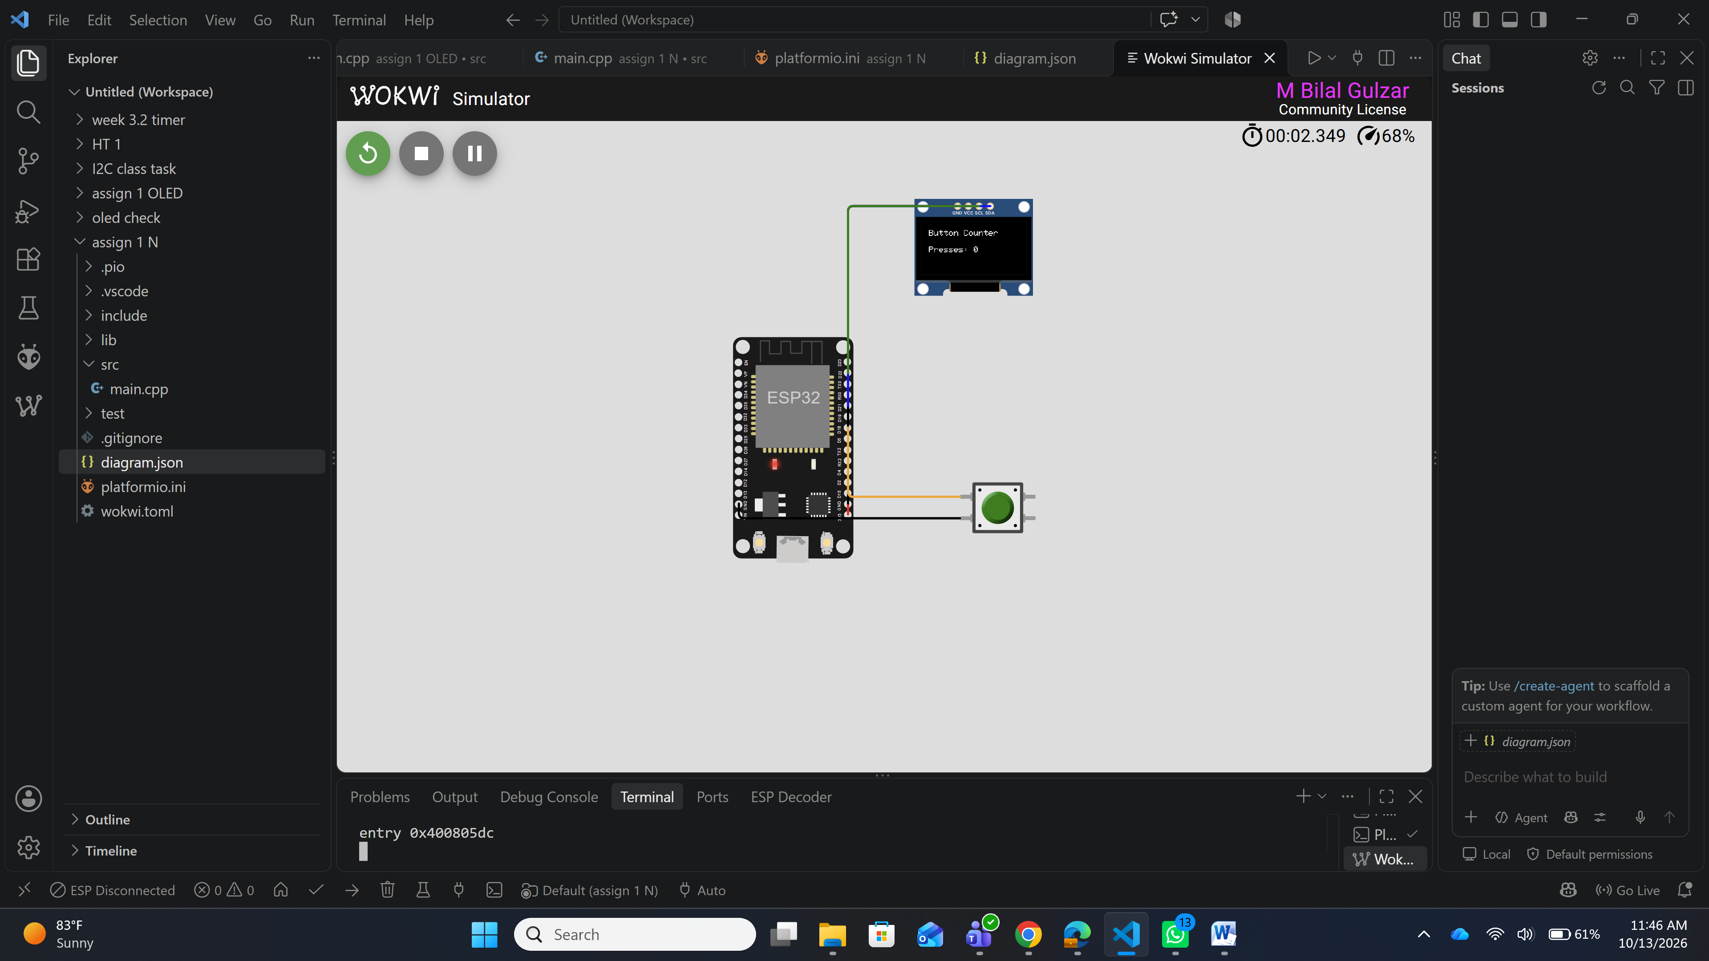No_W1_WokwiCircuit.png
Figure W1 – Wokwi circuit showing the ESP32, SSD1306 OLED and push button with all wires connected.
W2 – Wokwi output.
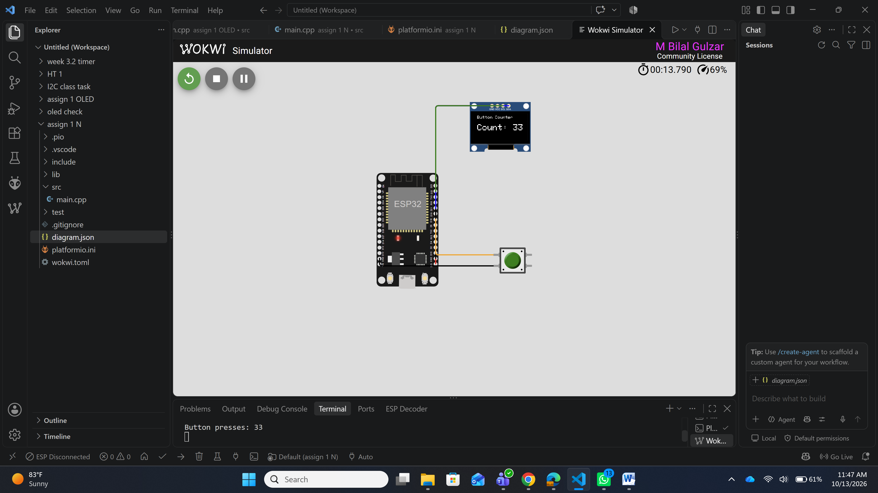
Figure W2 – Running Wokwi simulation – OLED shows the status and a non-zero press count.
W3 – VS Code / PlatformIO
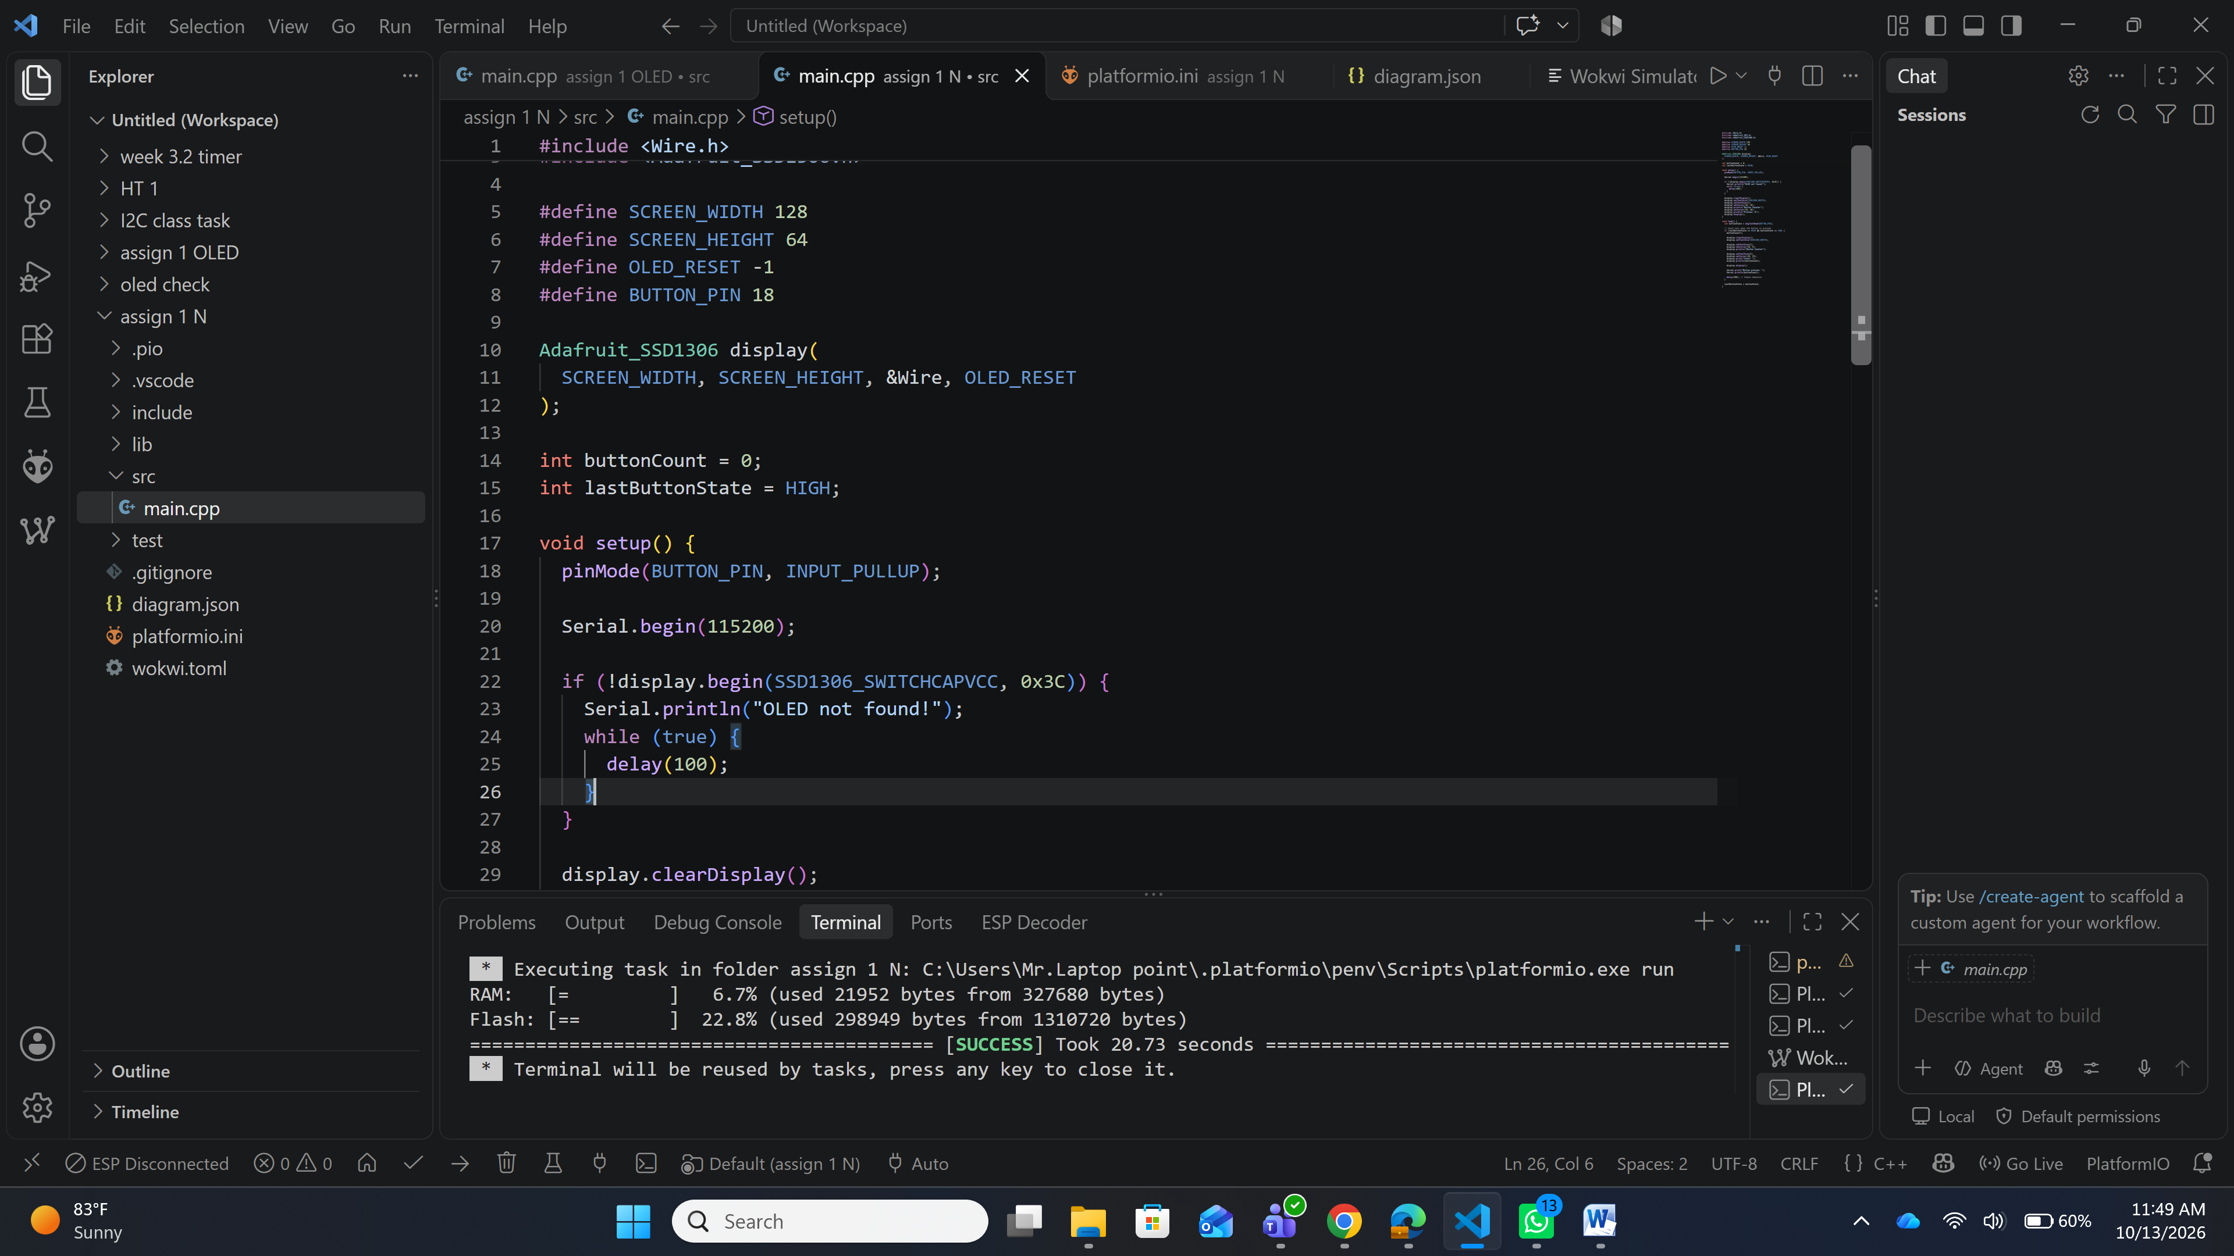
Figure W3 – PlatformIO project structure and successful build in VS Code.
H1 – Hardware setup
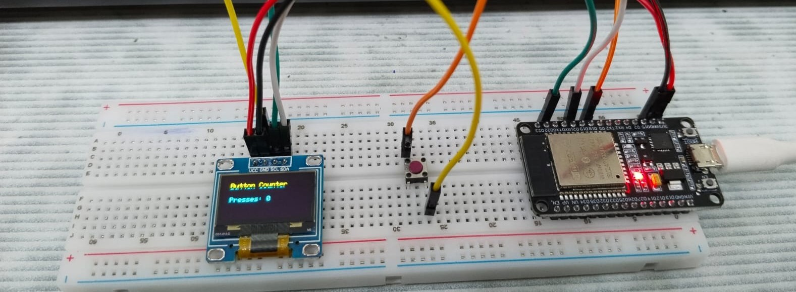
Figure H1 – Physical ESP32 kit wired to the SSD1306 OLED and push button.
H2 – Hardware output
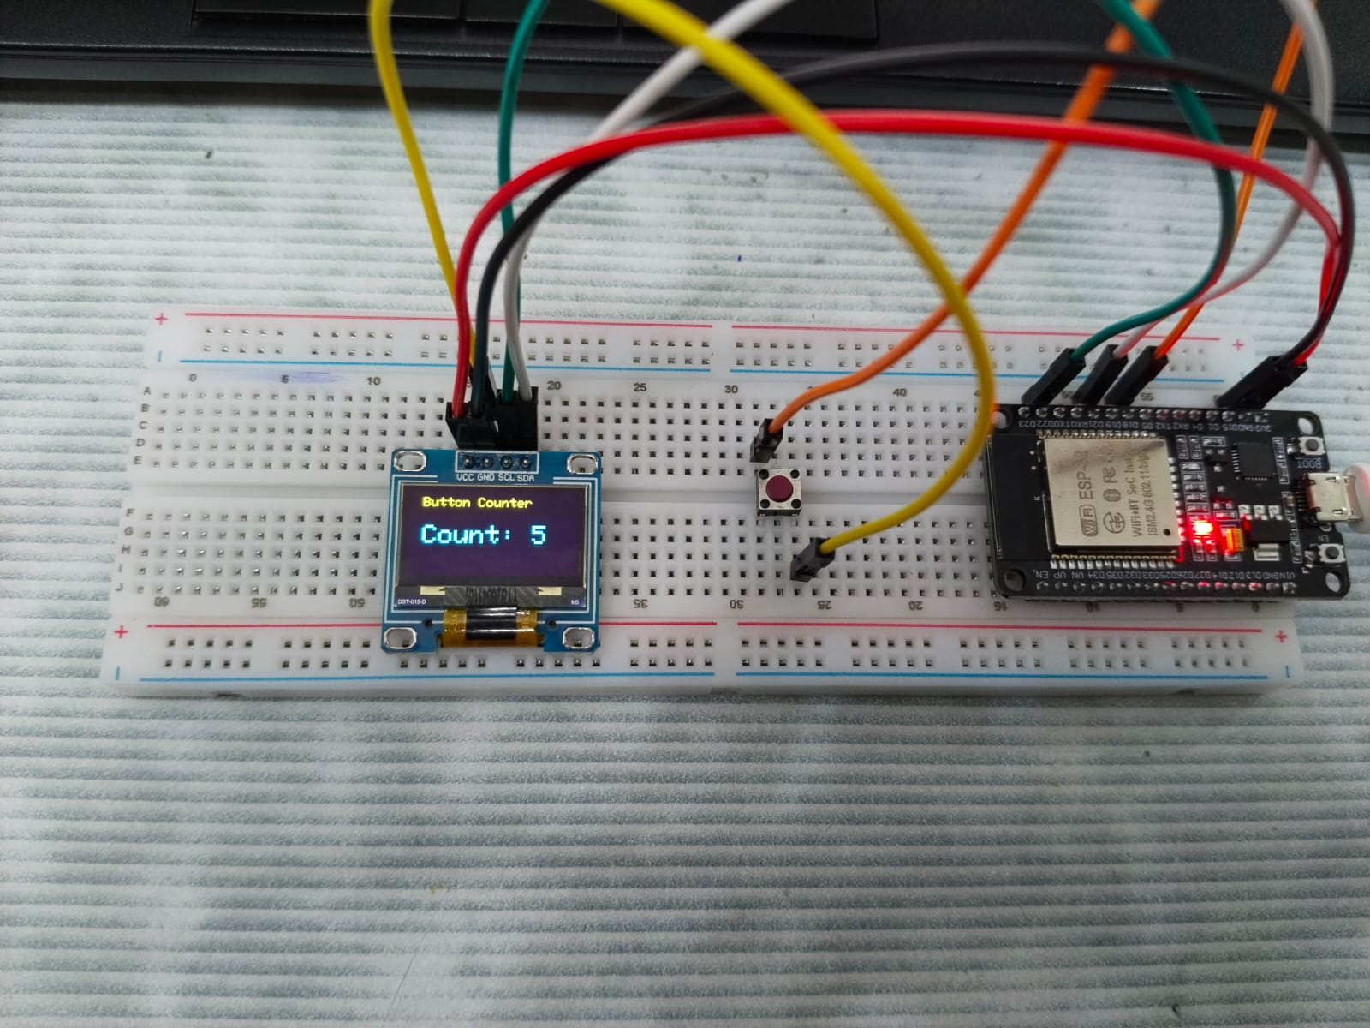
Figure H2 – Real OLED showing the status and a non-zero press count on the hardware kit.
H3 – Hardware test (Serial Monitor).

Figure H3 – Serial Monitor output on hardware showing each accepted press and its count.

Final Checklist
☑ | I answered all five theory questions in my own words.
☑ | My code compiles and I tested it in Wokwi and on the physical kit.
☑ | The button count increases exactly once for each valid press.
☑ | I included all required Wokwi screenshots and original hardware photos.
☑ | Every evidence image has a caption and follows the requested file-naming convention.
☑ | I included the complete project folder (platformio.ini, src/main.cpp, diagram.json, wokwi.toml) and checked that the files open correctly.

